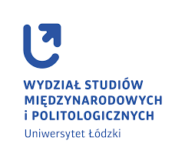
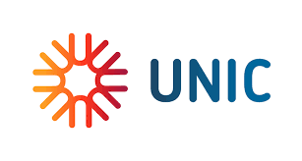

Blended Intensive Programme (BIP) – Lyon
Mobility and migration through time 2023

Classes at Lyon II University from 13/05/24 to 17/05/24
Online classes – March and April (selected dates, students will be informed)

Student’s application
An application should be sent January 11th, 2024 to dr Agata Włodarska-Frykowska email: agata.wlodarska@uni.lodz.pl

Name and surname

University email
- Study programme/year

- BA or MA

- Languages and level (A1/A3/B1/B2/C1/C2)

- Participation in mobility programs

- other experience in international activities

